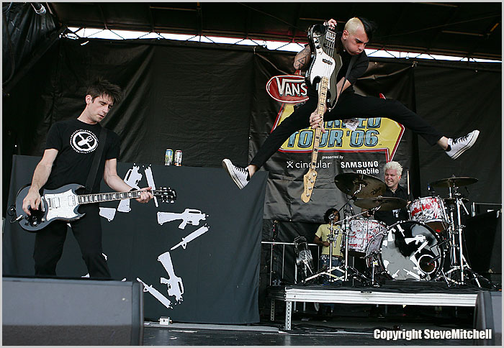
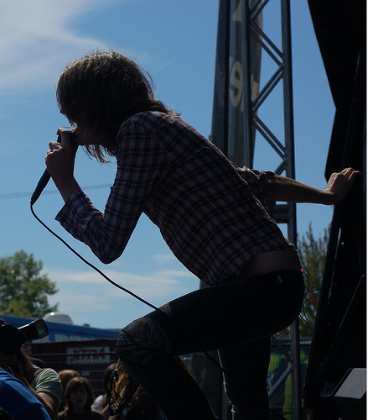
WARPED TOUR '08

After waiting countless enough of hours in a line filled with music fanatics, in thirty degree weather, and sweating like there’s no tomorrow, we were finally allowed inside- or onto- the flats of Arrow Hall. Once inside, the ambience was astounding… and varied. Feelings of anxiety, excitement, and fear were floating around the vast amount of space. These were due just to the fact that around the vast amount of space. These were due just to the fact that there was no grass like there usually is when Warped Tour was held at Molson Park in the past. Concrete was all the naked eye could see for miles around.

At 11:45 the first band came pounding onto the stage and surprisingly enough-for such an early time slot- it was a magor headliner. New From First to Last played an incredible show. Using music that could relate to old and new fans, the band got the energy started for the rest of the day. Playing some of their new songs off of their debut record, From First To Last, the band led into classics The Latest Plague, Note To Self, and Ride the Wings of Pestilence. Clearly playing without their previous lead singer (Sonny Moore) did not destroy their confidence in playing some of their older songs; in which he sang in all of them. From First to Last’s energy captivated the entire audience and were an impeccable band to have playing at 11:45 in the morning.
As soon as FFTL had finished playing, the rodies finished putting away the instrument, another phenomenal band made their way to the center of the Left 66 Vans stage. This small band known as The Academy Is… played an aw worthy song. Not awe, but aw. William Becket not only captured young girls hearts with his prince charming looks, but stole them and crushed them when he walked off stage forty five minutes later. However back to the music aspect of the band, The Acadamy Is… never fails. Playing hits like Attention and Slow Down, the crowd could be heard over the instruments and over William Beckets angelical voice. Although, it did lack the emotional aspect which every live band must have. The way that the band performed was like looking into a mirror. Yeah you sang the words back just as fiercely and yes you did cry when he took off his shirt but a pretty boy image is destroying the true talent that this band has. I mean how many times do you hear people talking about The Acaemy Is… and not William Beckett. The band can no longer be taken seriously. Just look at what you’ve just read.
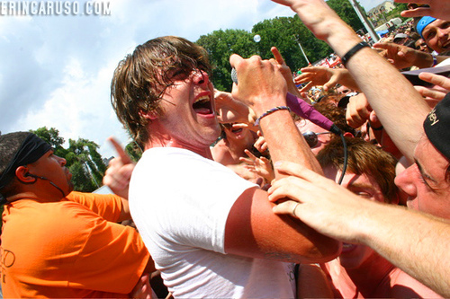

On the same stage, directly following the past two energetic and fun bands was a whole different kind of band. Norma Jean had to be the second greatest band that played that day. Their music is amazing and unlike a certain pretty band (cough, cough) their emotion hit home deep. They created such a connection with their audience it was struck awe in everyone. Screaming directions from lead singer Josh Scogin to open up the floor and create hard core circle pits only intensified the already intense fans and the mosh pits were incredible. Norma Jean not only put on a show, they connected with their audience and created such an open atmosphere that everyone forgot about everything except the music,,,and fighting for one’s life.

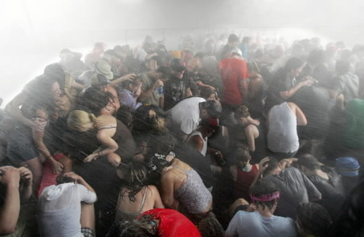
After a quick lunch break we were right back into the music scenes and found ourselves drift towards a small metal band called The Devil Wears Prada. To sum up their entire performance in three letters would be O-M-G. The Devil Wears Prada were absolutely magnificent. There was this energy in the crowd that other bands only dream of having. The music just made everyone in the audience want to beat the living crap out of someone for the hell of it and the song didn’t even have to be an angry song. The passion that the band held for music and not the industry, because as we all know, unfortunately they’re completely different. The Devil wears Prada just brought everything to the table and delivered it so well that they are a band who I would not mind seeing again.
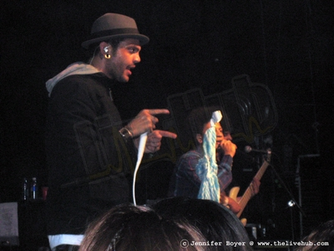
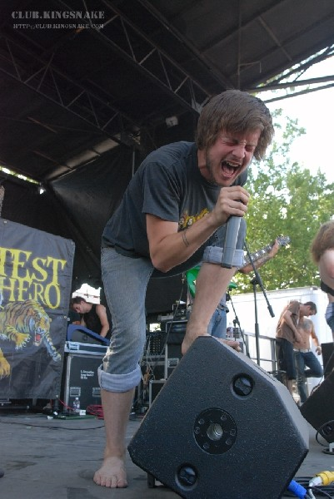

The most surpriing band of the day- in a good way- was Gym Class Heroes. Compared to most of the bands playing Warped Tour, Gym Class Heroes would be way out of their element, one would think. However the connection with the audience was unbelievable. People left the stage still singing the lyrics, horribly, but with fun and compassion. Lead Singer Travis McCoy reached out to the crowd and thanked them, giving nothing but gratitude, insisting that his fans were the reason he got sober. Out of all the metal andalternative and emo bands, this band was the most emotional and my third favourite band of the day. As we in the music non industry say… SCREW LABELS!

The most disappointing performance of the day was one of my favourite bands by the name of Protest The Hero. Technically it wasn’t their fault. Due to the hail and intense amount of rain, the mic turned off and so did the amp that connected to the guitar. Fans still stood in the hail and watched them but peope could barely make out what song was playing. That’s the only reason why their performance was such an epic let down. On the contrary, IT’S PROTEST THE HERO SO IT ROCKED!

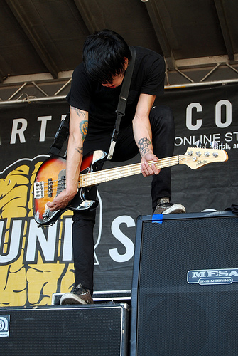
The last band of the day played such an amazing show. When asked by people how they were I mutter the words I can’t answer that due to the fact that they left me standing in the rain speechless. Playing classic songs like Tilting The Hourglass and new songs like This Is The Part Where You Are Suppposed To Scream, Alesana took the tour by storm. The energy was incredible and the band was down to earth. Lead vocals Dennis Lee kept repeating, “Wow stop looking at me. We’re not that good.” The mosh pits were insane and for one moment clarity was there. Clarity on segregation among the human race and clarity among genders and clarity of everything. For one small fraction everybody knew what everything meant. No one cared about black or white, jew or Christian, girl or guy. Everyone was brought together by the power of this band and all the others. Who says music doesen’t have the power to change the world? ALT

